Advanced Diploma in Digital Business Strategy and Management  DB301 Digital Business Strategies and Operations  Final Examination  (Written + Lab) | 

Name: _________________________Registration No.: ______________ Date: __________

Answer ALL questions.
Time: TWO Hours and 10 minutes reading time
Reference materials are NOT allowed.

Instructions:

- This examination paper consists of THREE (3) sections.
Section A. Multiple Choice Questions (20 Marks)
Section B. Short-Answer Questions (30 Marks)
Section C. Practical/Laboratory Questions (50 Marks)
- Answer ALL questions.
- Read each question carefully before answering.
- Write all answers clearly and concisely.
- Short-answers questions require brief and concise answers.
- Electronic devices, phones, internet access, translators and AI are NOT allowed unless otherwise required in some of the questions.
- Don’t forget to turn-in your practical/laboratory answers in the Google Classroom.
- Once you have completed all questions, submit your examination paper and answer sheets to the invigilator.
- The total marks for this paper are 100 marks.

Section A: Multiple Choice Questions (20 Marks)
Instructions: Choose the ONE best answer for each question.

1. Which statement best distinguishes digital business from traditional e-commerce?
A. Digital business only focuses on online payment processing.
B. Digital business focuses exclusively on digital marketing.
C. Digital business integrates technology across operations, supply chains, partners and customer touchpoints.
D. Digital business is simply a website with an online shopping cart.

2. Which sequence best represents the evolution of digital strategy?
A. AI → Web Presence → E-Commerce
B. Web Presence → E-Commerce → Digital Business
C. E-Commerce → Web Presence → Digital Business
D. Web Presence → Digital Business → E-Commerce

3. In a digital value network, customers are more likely to be viewed as:
A. Passive recipients
B. End points in a supply chain
C. Co-creators and ecosystem participants
D. Suppliers of physical inventory only

4. Which of the following is primarily a customer driver for digital transformation?
A. Cloud computing
B. Artificial intelligence
C. Demand for personalised and omnichannel experiences
D. Legacy hardware replacement

5. A Digital SWOT analysis places greater emphasis on which of the following?
A. Physical buildings and machinery only
B. Data assets and API ecosystems
C. Employee uniforms
D. Traditional distribution channels only

6. In a digital version of Porter's Five Forces, user lock-in can become important
because:

A. Users cannot access the Internet.
B. Platform network effects can increase switching barriers.
C. Physical assets always increase in value.
D. Digital products cannot have competitors.

7. Which of the following is an example of a Blue Ocean "Create" action?
A. Removing unnecessary physical branches
B. Reducing manual verification time
C. Improving existing website speed
D. Creating an entirely new digital value proposition

8. Which is NOT one of the four digital maturity pillars?
A. Digital culture and leadership
B. Technology stack architecture
C. Data and analytics capabilities
D. Physical warehouse expansion

9. What is the primary purpose of a multi-sided platform?
A. To manufacture all products internally
B. To connect distinct user groups to facilitate value exchange
C. To eliminate all external partners
D. To operate only through physical stores

10. Which example represents a positive network effect?
A. More sellers make a marketplace less useful to buyers.
B. More riders reduce the number of drivers available.
C. More participants on one side increase the value of the platform to another side.
D. More users always increase operating costs without creating value.

11. Which revenue structure is commonly associated with SaaS?
A. Subscription
B. One-time physical inventory sale only
C. Factory licensing only
D. Manual cash collection

12. Which is an important consideration in API ecosystem governance?
A. Eliminating all third-party developers
B. Balancing openness with security, compliance and revenue sharing
C. Preventing all external integrations
D. Avoiding data exchange completely

13. In Lean operations, "Muda" refers to:
A. Customer loyalty
B. Non-value-adding waste
C. Digital revenue
D. Network effects

14. Which task is most suitable for RPA?
A. A highly unpredictable strategic negotiation
B. A repetitive rule-based invoice matching process
C. Designing a new corporate strategy
D. Conducting a leadership interview

15. Customer journey mapping is primarily used to identify:
A. Employee salaries
B. Customer steps, pain points and digital touchpoints
C. Competitor financial statements
D. Network security protocols only

16. Which KPI is particularly relevant to order fulfilment performance?
A. OTIF
B. Number of employees
C. Office size
D. Number of company websites

17. Which technology captures real-time telemetry from physical assets?
A. Blockchain
B. IoT
C. SaaS
D. CRM

18. Which combination best represents the logistics architecture?
A. IoT → Cloud → AI
B. Blockchain → Website → Email
C. CRM → Spreadsheet → Printer
D. Website → Social Media → Payment Gateway

19. According to Rogers' Diffusion of Innovation framework, which group generally requires proven ROI and case studies?
A. Innovators
B. Early Adopters
C. Early Majority
D. Laggards

20. Which principle is central to Zero Trust?
A. Trust all internal users
B. Trust users once they enter the network
C. Never Trust, Always Verify
D. Give all users administrator access

Section B: Short Answer Questions (30 Marks)

Instructions:
- Answer all five questions.
- Each question carries 6 marks.
- Answers should demonstrate understanding, application and appropriate examples.
- Where applicable, use diagrams, tables or frameworks to support your answer.

Question 1 — Digital Business vs E-Commerce

Explain three major differences between traditional e-commerce and holistic digital business.

Your answer should address:
- Business scope
- Technology/operational integration
- Value creation

Give one practical business example to support your explanation.

Write your answers below:

Question 2 — Digital Strategic Analysis

A traditional retail company wants to compete with digital platforms.
Explain how TWO of the following strategic tools could be adapted for the digital environment:

- Digital SWOT
- Digital PESTLE
- Digital Porter's Five Forces

For each tool, explain one digital-specific factor that should be considered.

Write your answers below:

Question 3 — Digital Business Models

Explain how a company can move from a traditional linear business model towards a digital ecosystem or platform model.

Your answer should discuss:
- Changes to the value chain
- Role of data and technology
- Role of ecosystem partners
- At least one possible revenue model

Write your answers below:

Question 4 — Digital Operations

A company has a digital order fulfilment process with excessive waiting, redundant data entry and repeated manual approvals.

Explain how Lean and Agile principles could be used to improve the process.
Identify:
- Two types of digital waste
- Two process improvements
- One potential operational benefit

Write your answers below:

Question 5 — Strategic Technology and Security

Explain how Cloud Computing, AI, IoT and Blockchain can work together to improve a digital supply chain.

Then explain one Zero Trust principle that should be incorporated into the solution.

Write your answers below:

SECTION B — MARKING RUBRICS

Performance Level | Marks | Descriptor
Excellent | 5–6 | Accurate and comprehensive explanation; applies concepts correctly; provides relevant example(s); demonstrates strong strategic understanding.
Good | 4 | Mostly accurate explanation with good understanding; some application/examples provided; minor omissions.
Satisfactory | 3 | Basic understanding demonstrated; relevant concepts identified but explanation/application is limited.
Limited | 1–2 | Partial understanding; significant omissions, weak application or unclear explanation.
No evidence | 0 | Incorrect, irrelevant or no response.

Section C: Practical/Laboratory (50 Marks)

Platform: Google Classroom, Manus AI, Base44

EXAMINATION INSTRUCTIONS
Please read all instructions carefully before starting the examination.

1. Accessing the Examination
- Turn on your computer and ensure you have a stable internet connection.
- Open Google Chrome or another supported web browser.
- Log in to your Google Account using your email account.
- Go to Google Classroom.
- Join the examination class using the class code (irpxfuox) provided below.
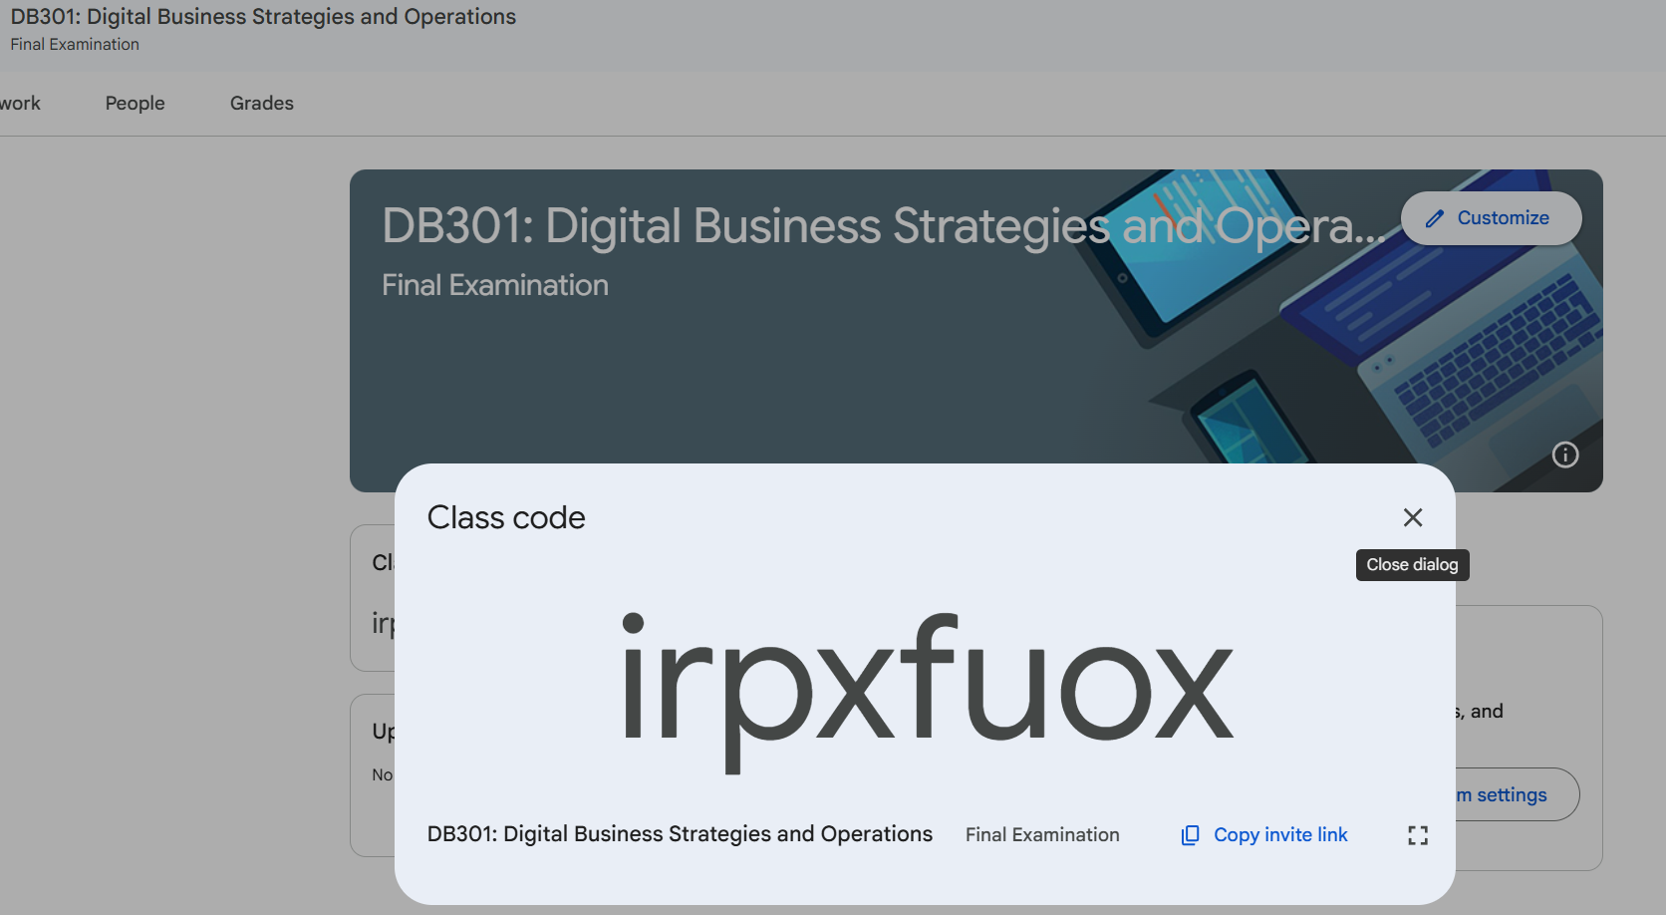
- After joining the class, click on the Classwork tab.
- Locate the assessment titled:
“Digital Business Strategies and Operations Practical FE”
- Carefully read all questions and begin answering the assessment.

2. Accounts Required
Before starting the examination, ensure that you are logged into the following accounts:
- Google Classroom
- Manus AI
- Base44
Students are responsible for ensuring they can successfully access all required accounts before beginning the examination. They can use their phones for authentication logins. After successful logins they are not allowed to use their phones.

3. Submission Instructions
- Go to Google Classroom
- Open the examination assignment
- Click Add or Create
- Click Links
- Add your Manus AI and/or Base44 links
- Add also your Google Slides for Task 1-2 and Task 4 answers
- Click Turn In.
- Confirm your submission.

4. Examination Rules
Students are expected to:
- Work independently.
- Follow all examination instructions.
- Complete all required tasks within the allocated time.
- Use professional language in all written responses.
- Ensure all submitted work is their own.
- Always maintain academic integrity.

Digital Business Workflow Automation System

This practical assessment requires students to analyse a business workflow and develop a working digital system that improves the workflow through automation, data integration, process tracking and dashboard reporting.

It applies concepts from the learning units, particularly Lean-Agile operations, RPA, digital workflows, customer journey optimisation, KPIs and technology enablement.

Case Study: Digital Order Fulfilment Management System

Background
SmartTech Supplies Pte. Ltd. is an electronics distributor that receives approximately 100–150 customer orders each day.

Currently, the company uses a combination of email, Excel spreadsheets and manual approval processes to process customer orders.

The current workflow is:

Customer submits order
↓
Sales staff receives email
↓
Sales staff manually enters order into Excel
↓
Sales Manager checks and approves order
↓
Warehouse checks stock manually
↓
If stock available
↓
Warehouse prepares order
↓
Delivery staff receives delivery instruction
↓
Order delivered
↓
Sales staff manually updates Excel
↓
Customer receives delivery confirmation

If stock is unavailable:

Warehouse identifies insufficient stock
↓
Sales staff contacts supplier
↓
Supplier provides estimated availability
↓
Sales staff contacts customer
↓
Customer decides whether to wait/cancel
↓
Sales staff updates Excel manually

Problems with the Existing Workflow

The management team has identified the following problems:
- Duplicate data entry
- Long approval waiting time
- Manual stock checking
- Difficulty tracking order status
- Customers frequently ask for order updates
- High possibility of data-entry errors
- Management does not have real-time performance information
- Staff spend significant time performing repetitive administrative tasks

Practical/Laboratory Requirements for student(s):

Task 1:
Identify at least FOUR forms of waste in the existing workflow.
Examples include:

- Waiting
- Duplicate data entry
- Overprocessing
- Manual checking
- Unnecessary communication
- Data movement
- Error correction

Task 2:
Create:
- Current workflow diagram
- Proposed digital workflow diagram
Your proposed workflow must show where automation is introduced.

Note: For Task 1 and Task 2, write your answers in Google Slides

Task 3:
Analyse the existing workflow and develop a system prototype of Digital Order Fulfilment Management System using Manus AI or Base44 that improves the process. The system should replace unnecessary manual activities with a digital workflow.

Note:
You must think of the workflow prompt to use in Manus AI or Base 44 to generate the initial system prototype.

Submit the Manus AI or Base 44 link in the Google Classroom

Task 4:
After completing the system prototype, students must demonstrate how the system improves the original workflow.

Before vs. After
Complete the following table

Area | Existing Process | Proposed System | Improvement
Order entry | Manual Excel entry | Digital form
Approval | Manual/email | Digital approval
Stock checking | Manual | Automated
Order tracking | Phone/email | System status
Notifications | Manual | Automated
Reporting | Excel | Dashboard

Note: Write your answers in the Google Slides together with the answers for Task 1 and 2

SECTION C — MARKING RUBRICS

Component | Marks
A. Workflow Analysis | 10
B. Manus AI/Base 44 System Design and Development | 30
C. Process Improvement Analysis | 10
TOTAL | 50

<< End of Final Examination Paper>>

